**Madyson Bradford Web App:** [**https://tamu.maps.arcgis.com/apps/instant/basic/index.html?appid=37ac3d078df543cb9ce4991245414b08**](https://tamu.maps.arcgis.com/apps/instant/basic/index.html?appid=37ac3d078df543cb9ce4991245414b08)

**Below: Image from collector app.**

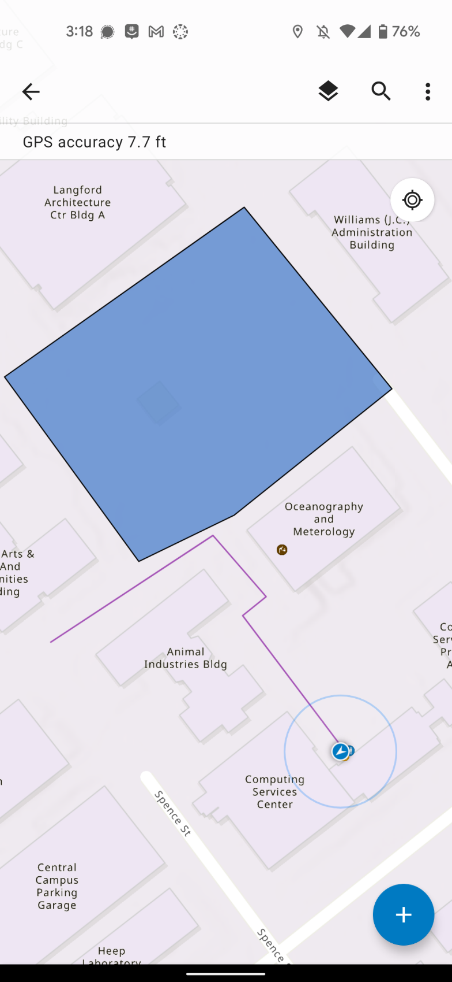

Picture from Collector App.